

Tittle: | Moving the error queue messages to normal queue
Product: | OSB
Customer: | IMPACT
Scope Of Change: | Moving the error queue messages to normal queue
Approval:

Document Control

1.1 Version History
Sl. No | Date | Author | Version | Change Reference

1.2 Reviewers
Sl. No | Reviewer | Position | Stream | Organization

1.3 Scope and Purpose of the document
This document is intended to provide procedure to move error queue messages in queues: “SADADDriver_BillerNotification_JMSQ_error” and “SADADDriver_BillNotFoundInBRMDB_ErrorQ” to the normal queue “SADADDRIVER_BillerNotification_JMSQ” for processing the messages.

1.4 Content
Table of Contents
1 Document Control 2
1.1 Version History 2
1.2 Reviewers 2
1.3 Scope and Purpose of the document 2
1.4 Content 3
2 System Overview 4
2.1 Introduction 4
2.2 System Impact 4
2.3 Operational Practice 4
2.4 Defeminations, Acronyms, Abbreviations 4
2.5 Assumptions, Dependencies, Constraints, Decisions 4
2.6 References 4
3 Step-by-step instructions 5
Appendix 10

System Overview

Introduction
The “SADADDRIVER_BillerNotification_JMSQ” is included in “JMS Modules”, a JMS modules contain configuration resources, such as standalone queue and topic destinations, distributed destinations, and connection factories, and are defined by XML documents that conform to the weblogic-jms.xsd schema.

System Impact
Operational procedures in this document can be performed at PROD environment when there are “messages pending” or “messages current” in any error queues: “SADADDriver_BillerNotification_JMSQ_error” and “SADADDriver_BillNotFoundInBRMDB_ErrorQ” to move them to the main queue and see if they finish processing.

Operational Practice
It is expected that operational staff check whether, once the messages in the error queues were moved to the main or normal queue, they have finished processing or are back in the error queues, if that happens, the problem should be reported, since moving messages from the error queues is not solving the issue.

Defeminations, Acronyms, Abbreviations

Assumptions, Dependencies, Constraints, Decisions
Sl. No | Assumptions
1. | There are “messages pending” or “messages current” in any error queues: “SADADDriver_BillerNotification_JMSQ_error” and “SADADDriver_BillNotFoundInBRMDB_ErrorQ”
2.

References
Sl. No | Document Name | Document Description
1.
2.

Step-by-step instructions

The “SADADDRIVER_BillerNotification_JMSQ” is included in “JMS Modules”, a JMS modules contain configuration resources, such as standalone queue and topic destinations, distributed destinations, and connection factories, and are defined by XML documents that conform to the weblogic-jms.xsd schema.

Operational procedures in this document can be performed at PROD environment when there are “messages pending” or “messages current” in any error queues: “SADADDriver_BillerNotification_JMSQ_error” and “SADADDriver_BillNotFoundInBRMDB_ErrorQ” to move them to the main queue and see if they finish processing.

Login to OSB http://172.20.10.38:7001/console
Go to JMS Module.

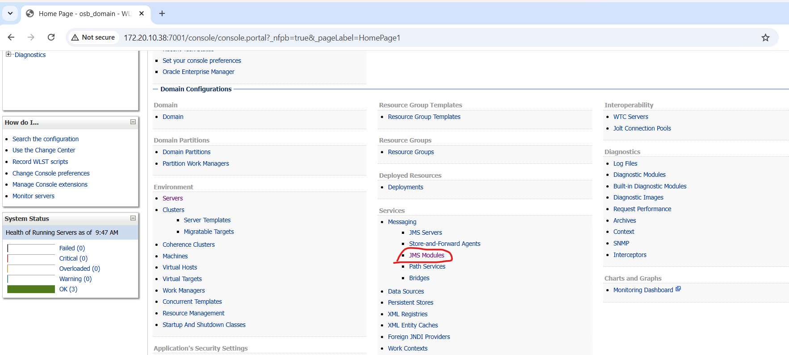

Steps to be followed
- Go to Semati_IB_JMSModule

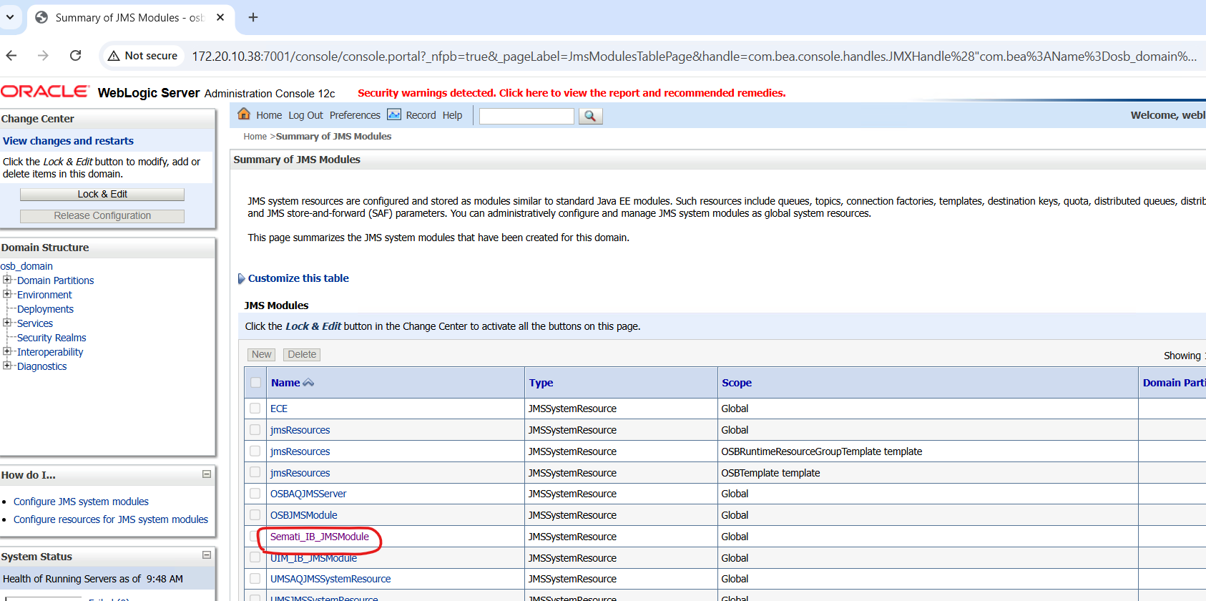

- Go to the error queue SADADDriver_BillerNotification_JMSQ_error or SADADDriver_BillNotFoundInBRMDB_ErrorQ
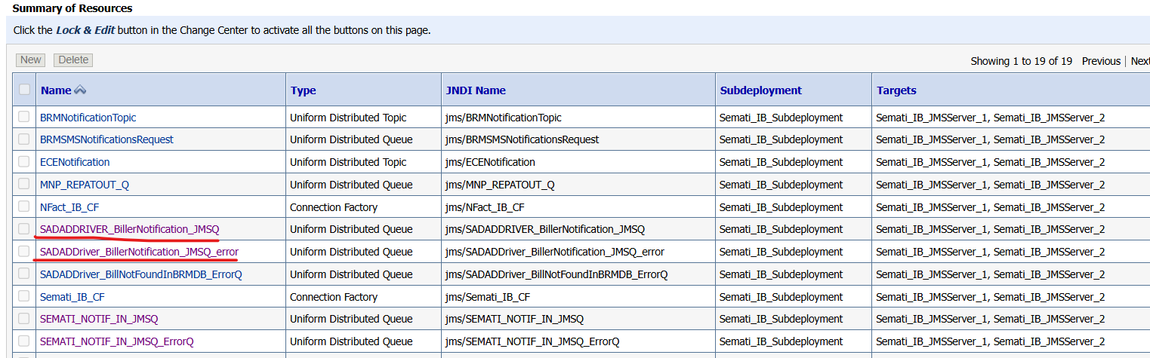
- Go to Monitoring.
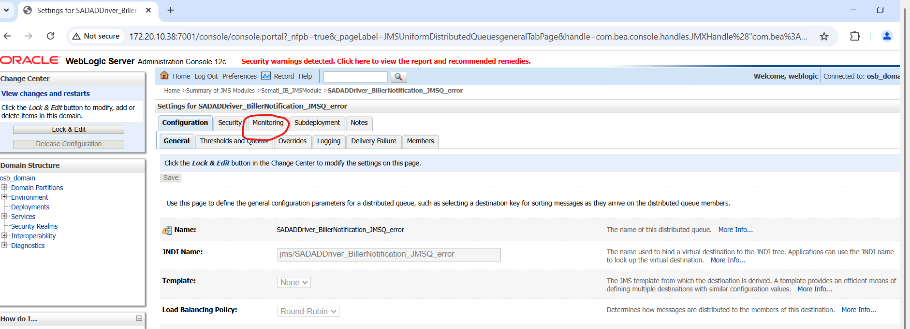

- Check if there are any pending messages under the Messages Current.
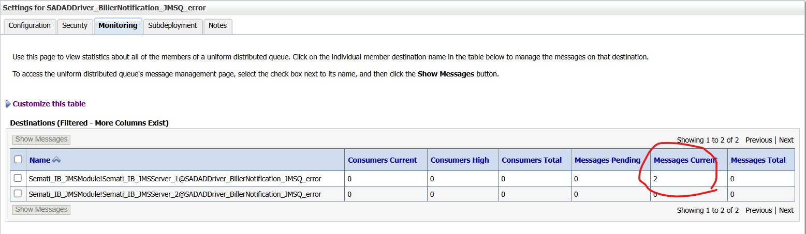

- If there are messages, select the check box where the count is displayed as shown below and click on Show Messages.
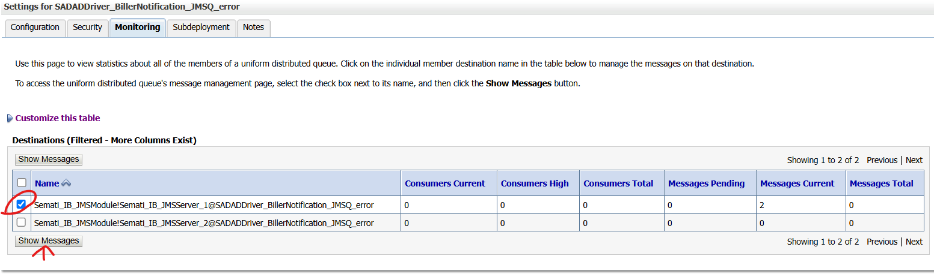
- Click on the ID as shown below and open the each message, which are available.
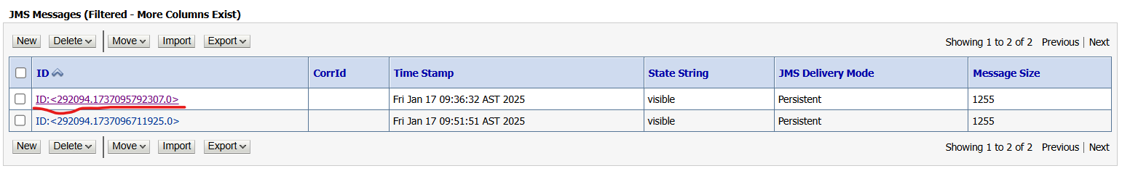
- Select the entire message and copy it to Notepad before processing it.
(This step is mandatory in order to do check the transactions which are processed by you).
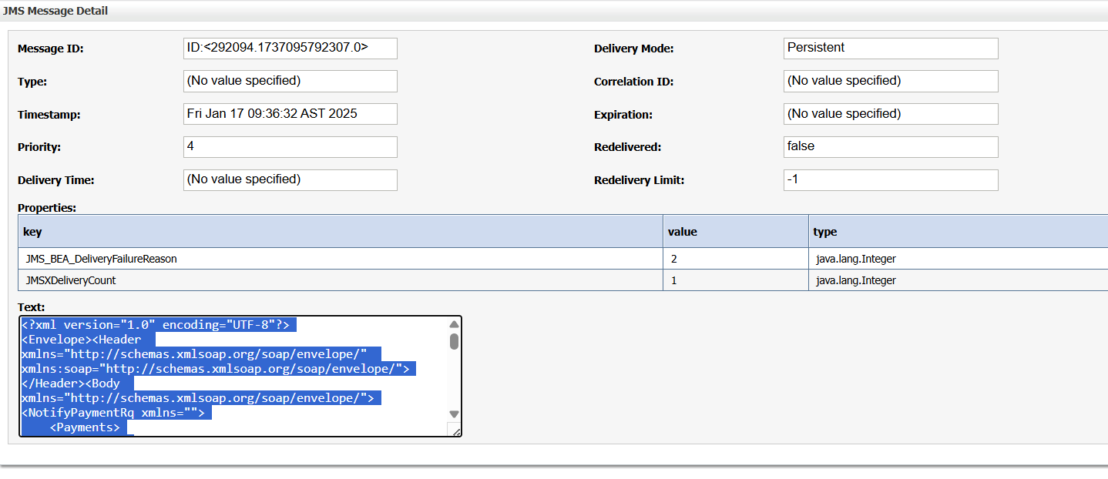

- Go back to the previous page and check the box as shown below and click on Move
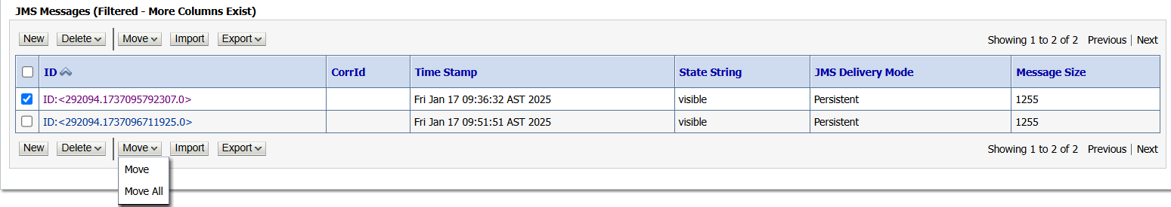
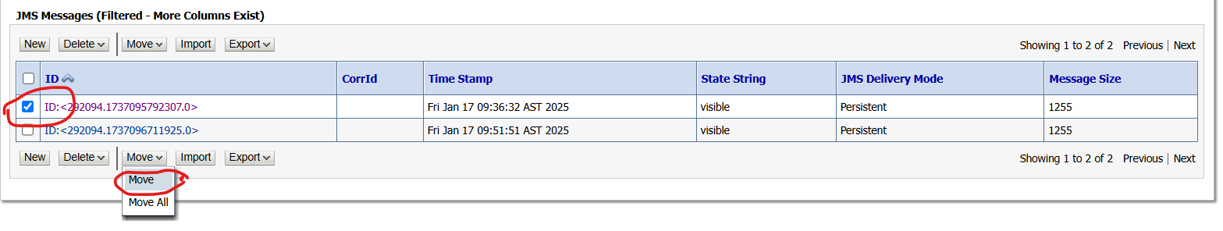
- Here select the JMS Server as Semati_IB_JMSServer_1 and click Next as shown below.
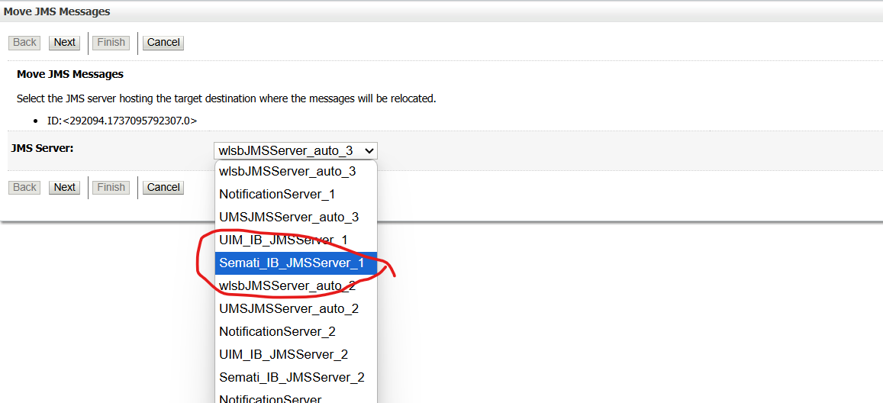

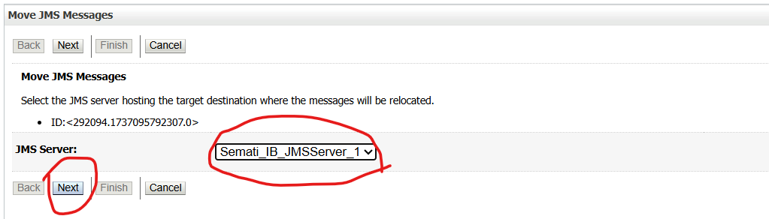

- Here select the Destination as Semati_IB_JMSModuleSemati_IB_JMSServer_1@SADADDRIVER_BillerNotification_JMSQ as shown below.
(Please be very careful and Mindful here and DO NOT select any other wrong queue)
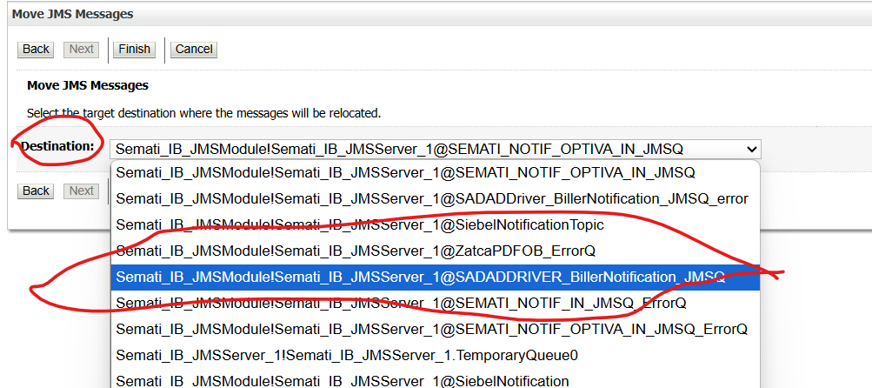

- Click on Finish.
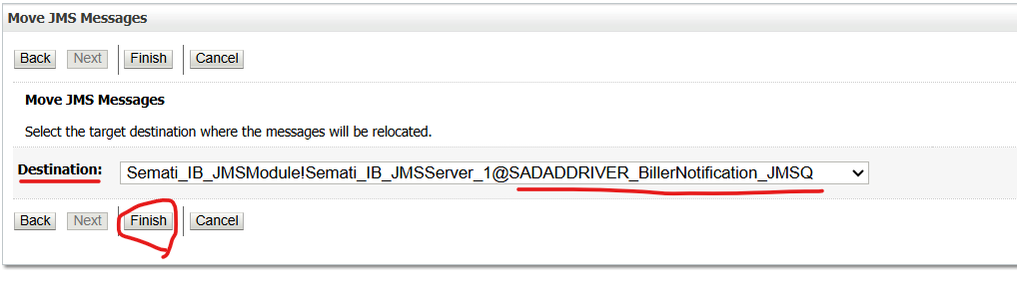
- Repeat all the messages in the error queue until you see below message.

Appendix
Ongoing Work
Sl. No. | Activity | Work Description | Owner

Common problems
Sl. No. | Defect/Bug ID | Identification Phase | Issue Resolution

Known Issues
Sl. No. | Defect/Bug ID | Identification Phase | Issue Resolution

